Title: Globalization and GVCs
Subject: EEP 7

1. History of World trade  2. Understanding modern Trade  A. Global Value Chains  B. Factors affecting sourcing decision  C. Possible Strategies  D. Risks  3. End of globalization?  4. EU Response: Open Strategic Autonomy | History of World trade  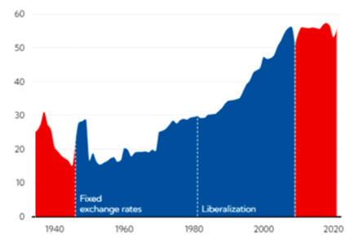  Consider Trade = (exports + imports) / GDP  A. 1945-1980: trade is growing faster than GDP  B. 1980-2000: greates development thanks to  i. huge tariffs reduction from GATT (40 to 15%) + reduction in costs of ICT (ex. calls)  ii. air transport cost reduction + development of container ships (larger)  iii. liberalization of FDI  C. 2010- : trade has flattened (Post globalization period). Surge of protectionism in the Us, the hearth of wto (founder and promoter), with Trump but also Biden. Due to:  - Idelogy: Make it in America with American workers, buy American, Innovate in America, Invest in America, Supply America (bring back critical supply chains to america)  - Trade War: Started by Us claiming that China is stealing IP, manypulating exchange rates, unfair trade practices  Understanding modern Trade  Global Value Chains: Trade is not firm in A produces smt and sells to firm in B  A value chain is the full range of activities that firms engage in to bring a product to the market, from conception to final use (from design, production, marketing, logistics and distribution to support the final customer).  Value chain are going global: Firms slice their production processes (the value chain) across countries. Key to Source inputs more efficiently and specialise, expand activities into new markets (Ricardo’s theory of comparative advantage). GVCs have made national economies very uintertwined and played a pivotal role in reducing poverty and creating growth in developing countries.  => Trade in intermediates nowadays dominates trade flows, representing 56% of trade in goods in OECD  Factors affecting sourcing decision  Labour cost, aboundance of key imports, access to H/S or L/S workforce, presence of infrastructure, Good institutions (eg, protection of IP rights), Proximity to large markets, possible geopolitical risks, raw materials  Possible Responses  Diversification: Enlarging the number of suppliers and countries involved in the value chain.  Nearshoring: shortening the value chain (from china to mex)  Friendshoring: strengthening trade relationships with allies and trusted countries.  Reshoring: bringing productive activities "home."  De-risking: a soft decoupling.  De-coupling (excessive): complete cutting off between the US-centered economies and the China-centered ones.  Risks  Visibility issues: GVCs have many tiers and layers. Building a car requires many components, each produced by a diff supplier. Each suppliers has its suppliers. Companies at the top of the layer: just a tiny chip can halt the prod of a car that is 99% ready.  Natural disasters, pandemics, Geopolitical uncertainties  Oil price fluctuations, trade disrtuptions (Houthi)  Low inventories  => clearly exposure depends on many variables, like geographic dispersion/concentration and trade intensity with trade partners.  The economic outlook has been degradating recently:  - After Covid-19 and China’s zero covid policy: we discovered how reliant we were to Chinese production.  -- After Russia’s invasion of Ukraine  --- This year: Hamas, Trump Mercantilism, Houthi, failure of Doha rounds,  => world now is no longer efficiency but resilience (ie, the ability to withstand disruptions, find back up solutions)  Consequences:  Strategic autonomy in key industries ex pharma, semiconductors  Diversify, solidify, strengthen the security of supply  Reshoring (but you need to produce tons of things + we lack many raw materials!)  Flexibility in production  Stockpiling  Eu Response = Open strategic autonomy (general direction for future trade strategy):  An “Open, Sustainable and Assertive Trade Policy”. Idea: Open and free trade BUT focus on resilience + protection from unfair practices. Six policy areas:  Reform Wto (ex. restore with a reformed appellate body)  Support green transition and promote responsible and sust value chains (ex. CBAM)  Support digital transition (ex. pushing a wto agreement on digital trade )  ‘Export’ EU standards = ‘Brussels effect’ (standards to enter eu mkt)  Partnerships with neighboring countries such as Africa  Focus on enforcement of trade agreements, and ensure a level playing field.

